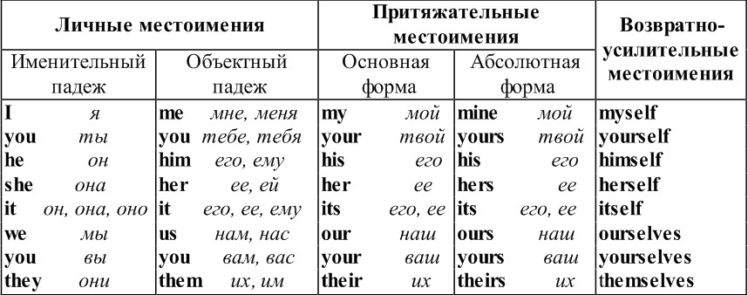

1. Fill the gaps with personal or reflexive pronouns.
1 . He is quit right, I agree with … completely.
2 . I looked at … in the mirror and left the house in a very good mood.
3 . “Who is it?” — “It’s … may I come in?”
4 . Mr. Lloyds is very fat … weighs over a hundred kilos?
5 . … introduced his wife to the quests.
6 . Where shall … meet, Bob?
7 . James took the book and opened ….
8 . We don’t dress … for dinner here.
9 . I taught … to play the quitar.
10 . Selfish people only care about …

2. Complete the sentences using possessive pronouns (my, your, his, her, our, their).

1 . I left … car in the garage.
2 . Mary hung … coat on the peg.
3 . Jack had … hair cut.
4 . Neil and David ate … supper.
5 . I hope you enjoy … holiday.
6 . We’ll invite you round to … house sometime and complete these by addig a possessive with own.
7 . You must make up … own mind.
8 . The children had to cook … own supper.
9 . Bill borrowed Jenny’s car … own can was being repaired.
10 . I’ll bring … own sheets and towels.
11 . Every dog had … own special basket to sleep in.
12 . You should do … own washing up.

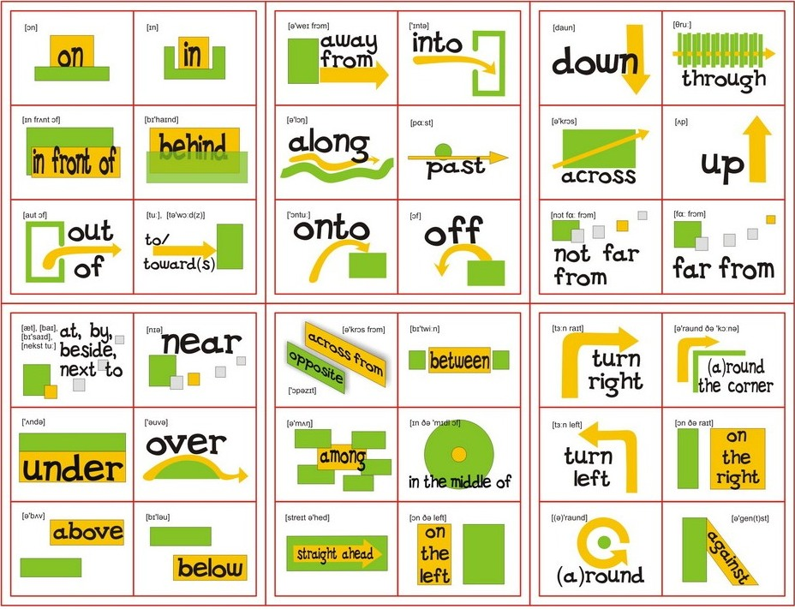
1. Поставьте необходимые предлоги в предложения.
about in at with to of for on
- My sister will arrive … the station … 9 o’clock … the morning.
- Look … that beautiful photo … my baby daughter.
- I’m hungry. What’s … lunch today?
- This is the highest mountain … the world.
- What do you usually do … weekends?
- We are going … the party … Saturday.
- I bought a new pair … sunglasses … the chemist’s.
- What do you know … Scotland? The postman came … a letter … my Dad.
- Did you speak … the boss … your salary?
- Sam lives … home … his mother.
- Can you help me … my drawing? - … course I can.
- I met my future husband … a queue … the bus stop.
- Justin is … Kristy’s house.
- The diagram is … page 76 … the left.

2. Выберите из скобок подходящий предлог.
- Does she come … (at/in/to) school … (on/by/in) bus?
- My office is … (near/near to/near with) the stadium.
- Kevin often goes abroad … (in/on/for) business.
- All the notices in the streets were … (on/by/in) French.
- What’s interesting … (on/in/at) TV … (on/at/in) the moment?
- Sorry. I took your bag … (on/for/by) mistake.
- Shall we go … (for/on/to) a walk?
- Kira is happy, she is … (on/in/with) love.
- We are waiting … (for/at/by) the rain to stop.
- Is Sophie good … (in/on/at) roller-skating?
- Is Tim interested … (at/in/by) marketing?
- I’m afraid … (by/with/of) big crowds of people.
- The forest was full … (with/of/by) mosquitoes.
- The patients are listening … (of/to/at) Mozart.
- Our plans depend … (on/from/in) the weather.
- We are … (out/of/out of) peaches. Could you go and buy some?
- I guess he annoys me … (for/on/in) purpose.

